**Idea Proposal**

[Maximum 200 words/answer]

Names: Carl Cai, Erin Sorbella, Zia Joseph

Topic:

1. What is/are the problem/s you want to solve? Why is it important?

We believe that the students aren’t as keen as they should regarding their own finances. They aren’t aware of how much they are spending and they don’t know how to use it more efficiently. If they don’t develop the sense of using money wisely, it will cause greater issues as they age.

1. Who are the users you are targeting?

Our primary target will be college students but the app will be applicable to all other users if they have an interest in monitoring and planning their finances.

1. How will this app solve the tackled problem/s? Provide a vision statement.

Our app intends to enable its users to have better financial literacy by providing a visualization of their own finances. It will encourage reflection, motivation, and future planning that allow them to use their spending in an efficient manner.

1. What are the major features of the app?

The user may set long-term goals that they want to achieve before a certain deadline. By taking the user’s expenses and income, the app will create a projection on whether the goal can be achieved before the deadline.

If not, it will show how much the user will need in order to achieve this goal. The user can also make short-term goals to help them in the process.  
The app will also provide visualizations of the user’s expenses and income in terms of percentages. The user can look at the data and interpret them however they like.

1. What similar apps exist on the market? (at least 2 apps with names, screenshots, links, descriptions, and how different they are from what you want to do)

https://www.wally.me/

Wally is a budgeting app that shows the user how much they have spent as well as their overall financial situation. 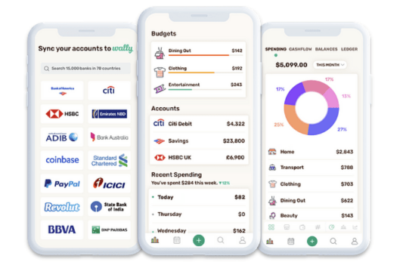

Our app differs by allowing the user to create long-term goals and short-term goals that further encourage the user to take action.

https://mint.intuit.com/

Mint is another similar budgeting app that tracks the user’s overall finances. Mint can be used to make payments for their bills and even allows users to check their credit scores.

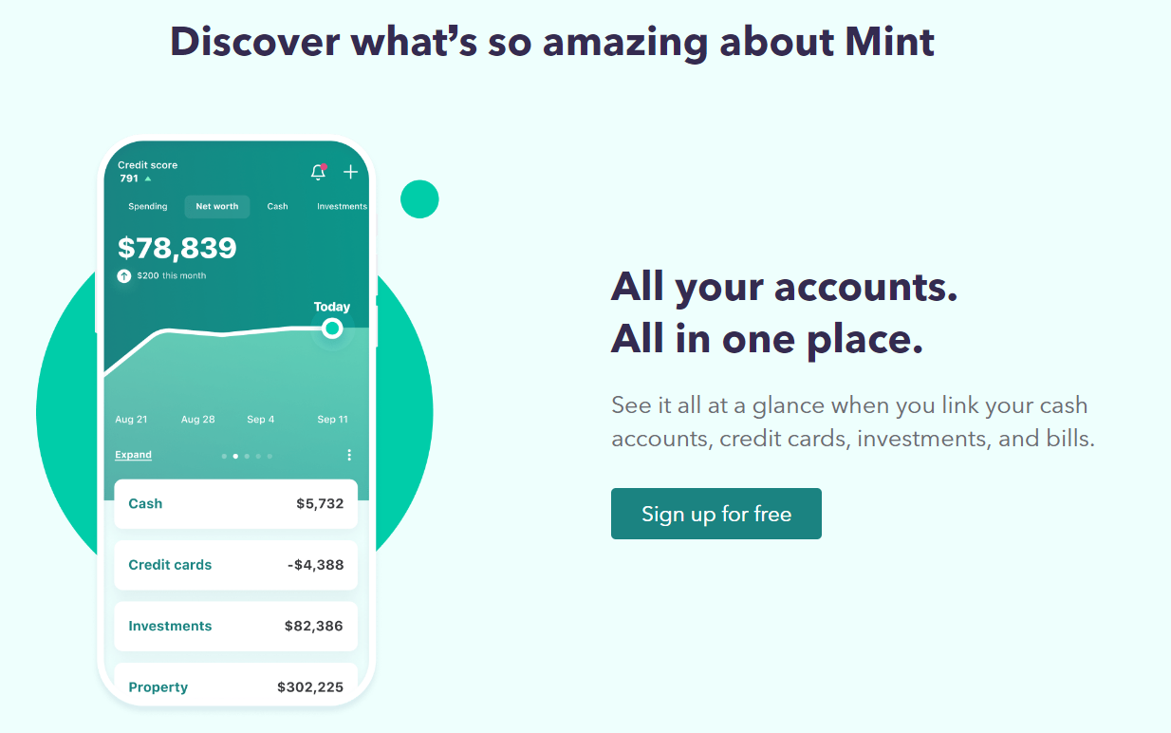

As Mint tracks every piece of information about the user, our app works completely based on the user’s input. It is not necessary for the user to enter all of their income or expense. They may enter only what they want to focus on and improve on.

1. How is your app unique?

Unlike other apps that require the user’s personal information, such as bank accounts, our app only uses the information provides to us by the user. The app will only run calculations on the data the user provides us. We will only provide unbiased statistics for the user to interpret and make decisions on their own.

1. What are the risks associated with the development of this app? Why wouldn’t it be delivered completely (scope), on time, and on a budget? Identify 3 to 5 risks that are relevant in your case.

Firstly, security would be a concern. The user’s information on the app is completely confidential and a security breach would be a serious issue.

Second, although we do not intend to share the user’s information, there may be misunderstandings that could cause unwanted issues. Hence, we will need to consult with a law firm for our terms of service, which we do not have the budget for.

Lastly, we need to patent our app to ensure no other clones of the app are made to phish our user’s data. Which will take more time and budget.

1. What is your (personal) goal with this project? (build portfolio/resume, get experience in mobile app dev …)

Our goal is to get familiar with developing an app that’s based on a real-world problem in a team setting and with limited time constraints. This will let us get experience with working on a project in a team setting as well as communication skills.